Vegan Besan Ladoo

Chickpea Flour Sweet Fudge Balls

Yield: 15-20 Fudge Balls Prep-time 5 minutes Cook-time 40 minutes
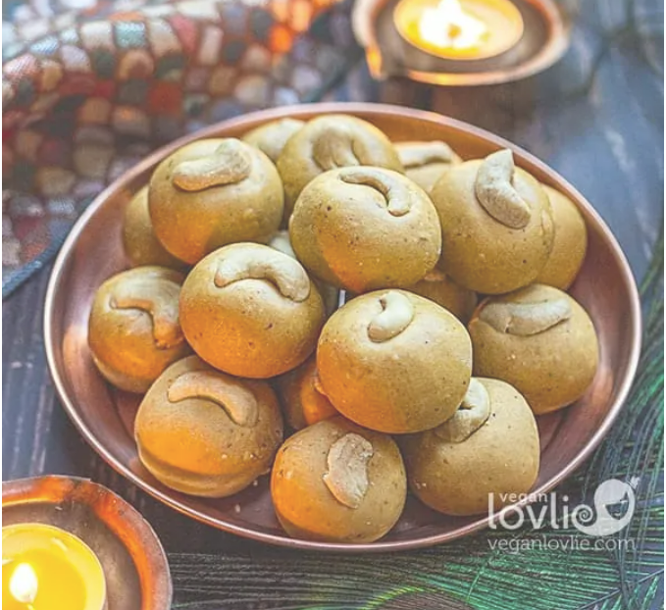
Ingredients

200 g (2 cups) besan (gram or chickpea flour)
120 ml (½ cup) virgin/unrefined coconut oil, add more if required
2 tablespoons hot water
175 g (1 cup heaped) powdered sugar (powder ¾ cup white sugar or raw sugar in a mixer-grinder, small blender)
½ teaspoon cardamom powder, or seeds from 6 to 8 green cardamoms, powdered in a mortar-pestle
70 g (½ cup) cashews – finely chopped or powdered, omit for nut-free version
Handful of slivered cashews for garnish, use raisins or toasted coconut for nut-free version

Instructions

- Sift the besan into a heavy bottom pan, press all the lumps through the sieve.

- Turn the heat on medium-low or medium and dry roast the besan while stirring steadily for about 10 to 12 minutes. Keep on stirring continuously for the whole time, so that the besan doesn’t burn and cooks evenly. You should notice a slight colour change and a nutty aroma being released.

- After 12 minutes of dry roasting, add the coconut oil. Stir and mix very well and continue roasting the besan for an additional 12 to 15 minutes, continuously stirring.

- The mixture will start releasing the coconut oil and will give a nice fragrant nutty aroma. The mixture will also tend to loosen on the sides of the pan and become one big lump. That’s when you know the besan is fully cooked. Once that happens, add the water and stir. The texture will change slightly and that’s what we want.

- Remove the pan from the stove-top and place it on your kitchen countertop to cool down. You may also transfer this mixture in a bowl and leave it in the refrigerator or freezer for a short while, to cool down completely.

- Once completely cooled, add the powdered sugar, cardamom, and cashews. Mix firmly with some strength from your hands. You have to mix this part vigorously so that the powdered sugar is well incorporated in the roasted besan and ghee mixture and no lumps are formed.

- Once you have mixed the ladoo mixture well, take a tablespoon or two of the mixture (depending on the size you want to make), start pressing and forming balls between the palms of your hands. Roll into smooth balls and place them on a plate.

- If the mixture is too dry to form balls, add a tablespoon or two of melted coconut oil. If the mixture is too runny, add a little more well roasted besan and powdered sugar.

- Press in a slivered cashew or raisin onto each ladoo. Refrigerate for about 30 minutes. Refrigerating them will make them firmer. So, if you prefer them softer, let them thaw for some time before serving.

